

The 15th International Symposium on Geo-disaster Reduction

(Bulletin 1)

Overview
The 15th International Symposium on Geo-disaster Reduction (15th IS-GdR) is an international platform for scholars, researchers and practitioners to discuss interdisciplinary research and practices in the fields of the reduction of the disasters triggered by geological and geophysical phenomena on the earth and beyond.

15th IS-GdR will take place on 26-31 August 2017 in Matsue City, Shimane Prefecture, Japan. Prospective authors are invited to submit original research abstracts or full papers.
- Date:
26-31 August 2017
- Organizers:
- Project Center on Natural Disasters Reduction, Shimane University, Matsue, Japan
- Joint International Center on Natural Hazard (JIC-Nh) of Shimane University, Beijing University of Technology and the University of Florence
- International Consortium on Geo-disaster Reduction (ICGdR)
- Co-organizers:
Recruiting (About 5)
(Geo-disaster related Institute or University or Project, about 300,000 JPY per institution, interested parties please contact: secretariat@icgdr.com)

- Sponsors:
Recruiting (About 10)
(Geo-disaster related company, about 150,000 JPY per company, interested parties please contact: secretariat@icgdr.com)
- Organizing Committee
Chair Person:
Fawu Wang (Director, Project Center on Natural Disasters Reduction, Shimane University)
Vice Chair Persons:
To be decided (from co-organizers)
Committee Members:
Zili Dai, Kun Song, Hufeng Yang, Shuai Zhang, and others from co-organizers
- Academic Advisory Committee
Members:
Yukikuni AKISHIGE (Vice President of Shimane University, Japan)
Jingshan BO (President of China Institute of Disaster Prevention, China)
Scott F. BURNS (President of IAEG)
Paolo CANUTI (Emeritus Professor of University of Firenze, Italy)
Masahiro CHIGIRA (Professor, Disaster Prevention Research Institute, Kyoto University, Japan)
Peng CUI (Academician of Chinese Academy of Sciences)
Xiuli DU (Vice President of Beijing University of Technology, China)
Thomas GLADE (University of Vienna, Austria)
Fausto GUZZETTI (National Research Council, Rome, Italy)
Manchao HE (Academician of Chinese Academy of Sciences)
Srikantha HERATH (United Nations University-Tokyo)
Chuntang HOU (Deputy Director of Institute of Geomechanics, CAGS, China)
Runqiu HUANG (Vice President of Chengdu University of Science and Technology, China)
Yuanming LAI (Academician, Chinese Academy of Sciences)
Zhilin LI (Southwest Jiaotong University, China)
Dwikorita KARNAWATI (Vice President of Gadjah Mada University, Indonesia)
Lei NIE (School of Construction Engineering, Jilin University, China)
Jianbing PENG (School of Geology Engineering and Geomatics, Chang’an University, China)
Atula SENARATNE (Vice-Chancellor of University of Peradeniya, Sri Lanka)
Bin SHI (School of Earth Sciences and Engineering, Nanjing University, China)
Nicolas SITAR (University of California, Berkeley, USA)
Baitao SUN (Director of Institute of Engineering Mechanics, CEA, China)
Jun TAKEUCHI (Vice President of Shimane University, Japan)
Huiming TANG (Vice President of China University of Geosciences, Wuhan, China)
Sijing WANG (Academician, Chinese Academy of Engineering)
Faquan WU (Secretary-General of IAEG)
Koetsu YAMAZAKI (President of Kanazawa University, Japan)
Yueping YIN (President of International Consortium on Landslides)
Endi ZHAI (Chief Engineer for Civil Works, China Three Gorges Corporation)
and others
- Academic Committee
Chair Person:
Masakatsu Miyajima

Vice Chair Persons:
Matteo Berti, Nicola Casagli, Guangqi Chen, Ranjan Kumar Dahal, Faisal Fathani, Hans-Balder Havenith, Bin He, Siming He, Yu Huang, Michel Jaboyedoff, Yonggang Jia, Wenxing Jian, Hengxing Lan, Tonglu Li, Qiuhua Liang, Ko-Fei Liu, Sandro Moretti, Hyuck-Jin Park, Wei Shan, Jun Shen, Alexander Strom, Joong Ho Synn, Huiming Tang, Binod Tiwari, Vit Vilimek, Fawu Wang, Patrick Wassmer, Mike Winter, Qingbai Wu, Qiang Xu, Weilin Xu, Masaho Yoshida, and others

Committee Members:
Netra Prakash Bhandary, Guangzhu Cao, Byung-Gon Chae, Qiangong Cheng, Fuchu Dai, Zili Dai, Jianhui Deng, Xuanmei Fan, Yong Hong, Mingjian Hu, Bolin Huang, Jianhui Long, Tingkai Nian, Xiangjun Pei, Shengwen Qi, Wenhao Qi, Jusong Shi, Kun Song, Lijun Su, Ping Sun, Huabin Wang, Aiguo Xing, Chong Xu, Yan Xu, Hufeng Yang, and others.
- Secretariat
Zili Dai, Kun Song, Shuai Zhang, Hufeng Yang, Lu Zheng, and others from co-organizers

Program
- Key Dates
Call for Abstracts | 1 December 2016
Deadline for abstract submission | 15 April 2017
Notifications of Abstract Decisions, Registration and Accommodations Open | 30 April 2017
Online registration and accommodation open | 1 May 2017
Early Bird Registration Deadline | 15 June 2017
Deadline for standard registration | 31 July 2017
The 15th IS-GdR Symposium | 26-31 August 2017

- Topics
- Geo-disasters caused by earthquake
- Geo-disasters and climate change
- Geo-disasters related to volcanism
- Geo-disasters caused by human activities
- Landslides
- Tsunami
- Social resilience to disasters
- New technologies for geo-disaster reduction
- And other related topics
- Time table
Saturday, 26 August 2017
Registration | 14:00-18:00
Sunday, 27 August 2017
Registration | Whole day
Annual Meeting of ICGdR | 14:00-17:00
Monday, 28 August 2017
Opening Ceremony | 9:00-10:00
High Level Forum | 10:00-12:00
Keynote Lectures | 13:00-15:00
Technical Session 1 | 15:00-17:30
Young Researcher Forum 1 | 15:00-17:30
Welcome Banquet | 18:00-20:00
Tuesday, 29 August 2017
Technical Session 2 | 9:00-17:00
Young Researcher Forum 2 | 9:00-17:00
Closing Ceremony | 17:00-17:30
Wednesday-Thursday, 30-31 August 2017
Field Trip to Oki Island World Geo-park | Departure from Matsue at 9:00 am on 30 August
Field Trip to Oki Island World Geo-park | Come back to JR Matsue station at 18:30

Submission
- General Instructions
- Abstracts/papers must be written in English.
- Submitted abstracts/papers must be original.
- Author’s name and e-mail address must be supplied properly – these contact details will serve for further correspondence with the author(s).
- Submission system: (will be built soon)
- Submission Format
Full research papers and abstracts are welcome. The submission must meet the required format and cover the following:
1. Backgrounds/ Research goals / Objectives
2. Methods
3. Expected results/ conclusions/ contributions
4. Keywords

Abstract
The abstract should be a summary of your presentation. Please avoid scientific or engineering symbols, acronyms and bullets. The submission should be typed single-spaced in 12-point type Times New Roman in Microsoft Word file (*.doc/*docx). The length should be within 800 words in 2 pages (a temperate will be uploaded soon).

Full paper
The submission should be typed single-spaced in 12-point type Times New Roman in Microsoft Word file (*.doc/*docx). The length should be within 12 pages, including references, tables / charts and keywords (a temperate will be uploaded soon).

- Receipt Notification
Authors will be notified about the receiving of their abstract or full paper by e-mail automatically. In case the author does not receive confirmation e-mail within 24 hours, please check the spam folder. In case of no confirmation e-mail, please contact: secretariat@icgdr.com
- How to Submit Your Presentation at the Symposium:
Your presentation must be uploaded into the PC in your lecture room before the session will start.
During your lecture you will be using a Remote Controller for controlling your presentation.
Please note that we cannot guarantee the quality of Mac-based presentations. Please check in advance (2 hours before your session starts) to ensure Windows compatibility.
All presentations will be deleted from the entire PC used after the symposium.
15-minute presentation, 5-minute discussion.
WE KINDLY ASK ALL THE SPEAKERS TO KEEP THE TIME OF THEIR PRESENTATIONS!
- Poster Presentations
Posters will be on display in the Poster Area, which will be located in the symposium venue.
Poster session will be organized individually through sessions. Each presenter will have 2-3 minutes for very short presentation (only 2-3 slides). More information on site during the session.
Recommended poster size: A0 (841 × 1189 mm)
- Attention
  - Authors are required to certify that their papers represent original works and are previously unpublished elsewhere. Simultaneous submission to any other conference, workshop or journal is strictly prohibited.
  - Plagiarism and self-plagiarism are strictly prohibited. In order to protect intellectual property rights of others and the authors' own academic reputation, we are strongly against this ruthless conduct.
  - Authors should take responsibilities for their submissions. Any violations of the above regulations are criminal actions.
  - Submissions that do not meet/ follow the conference submission rules and format will be returned for modification.
  - Excellent papers will be recommended to the official journal of the ICGdR Geoenvironmental Disasters.
  - A number of excellent presentations will selected for reward.

Registration
Registration will be open as of 1 May 2017. Registration should be completed at the latest by 31 July 2017.
Note: All participants should register. There should be at least one registration for each paper.
- Registration Fees
Registration Fee | Early-Bird Payment  before 15 June 2017 | Regular Payment  After 16 June 2017
ICGdR Member | 25,000 JPY | 30,000 JPY
Non-Member | 30,000 JPY | 35,000 JPY
Student* | 13,000 JPY | 18,000 JPY
*Full-time student will be required to present a student ID (or another proof of full-time study) at check-in.
- Registration Fee Includes:
- Paper presentation
- Attendance to all technical sessions
- Conference program
- Name badge
- Symposium materials including Book of Abstracts
- Conference bag
- Certificate of presentation
- Certificate of attendance
- Lunches and coffee-breaks
- Welcome Cocktail
- Banquet
- What is not covered by the fee?
Field Trip to Oki Island World Geo-park, 15,000 JPY / per person (Dinner and hotel fees are not included. Tickets can be booked using our on-line registration system).
- Receipt
The receipt as a proof of payment will be issued at the registration desk during the conference.
- Certificate
*[Certificate of Presentation or Certificate of Attendance]
A certificate of attendance includes participant’s name and affiliation, certifying the participation in the conference.
A certificate of presentation indicates a presenter’s name, affiliation and the paper title that is presented in the scheduled session.
- Certificate Distribution
Oral presenters will receive a certificate of presentation from the session chair after their presentations or at the end of the session. Poster presenters will receive a certificate of presentation from the conference staff at the end of their poster session.
The certificate of presentation will not be issued, either at or after the conference, to authors whose papers are registered but not presented. Instead, the certificate of attendance will be provided after the conference.
If authors are not able to present their papers due to unavoidable circumstances, they shall provide the official certification document to request for the certificate of presentation. For more details, please contact the conference secretariat at secretariat@icgdr.com
- Cancellations and Refunds
The Symposium Secretariat must be notified by e-mail (secretariat@icgdr.com) or Fax (+81-852-32-6469) about the cancellation of the registration. Telephone cancellation will not be accepted. The appropriate refunds will be made after the Symposium.

The following cancellation conditions apply:
Cancellations received | Refund
Cancellations received by 15 June 2017 | 100%
Cancellations received from 16 June 2017 to 31 July 2017 | 50%
Cancellations received after 1 August 2017 | 0%

- Methods of Payment
Registration fees must be paid in JPY by one of the following methods: Credit Card, Bank Transfer, Cash.
All payments made by bank transfer have to be net of all bank charges. The payer pays the bank charges of their bank, and the beneficiary pays the charges of their bank, if any.

Venue
Terrsa, Matsue
http://www.sanbg.com/terrsa/
Address: 478-18, Asahi-cho, Matsue, Shimane 690-0003, Japan
(West side of North Exit of JR Matsue Station)
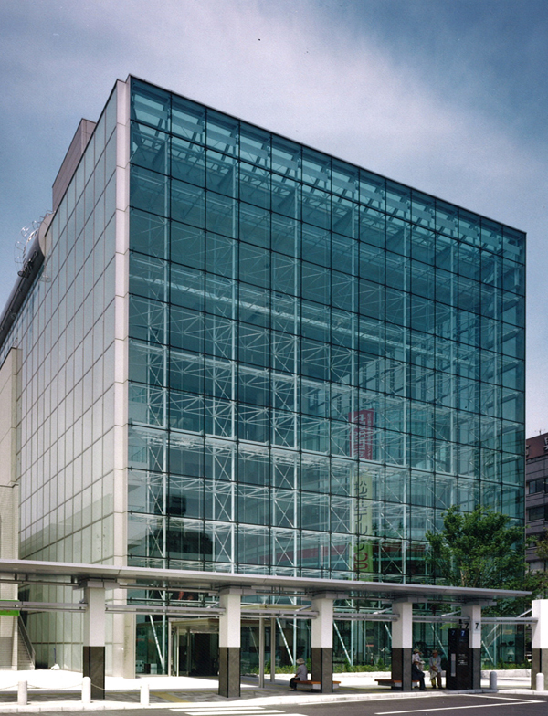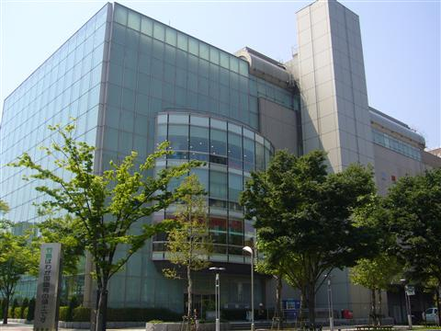

Trip
- Accommodations
Ichibata Hotel  http://www.ichibata.co.jp/hotel/ | 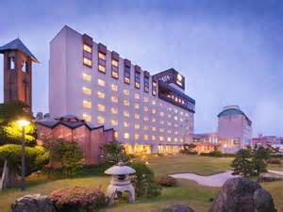
Green Rich Hotel Matsue Ekimae  http://www.gr-matsue.com/ | 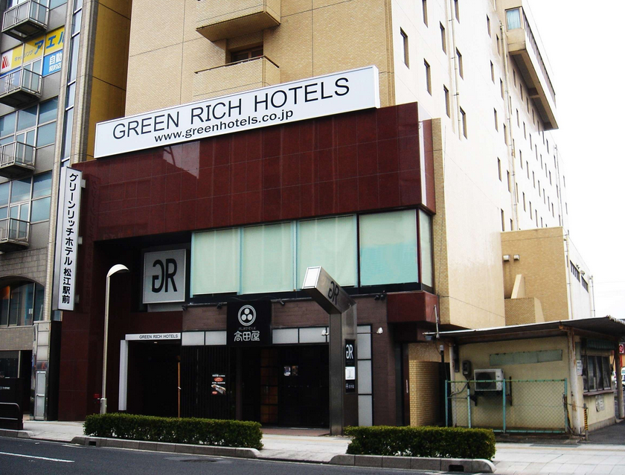
Hotel Alpha-1 Matsue  http://www.alpha-1.co.jp/matsue/  http://www.alpha-1.co.jp/matsue_2/ | 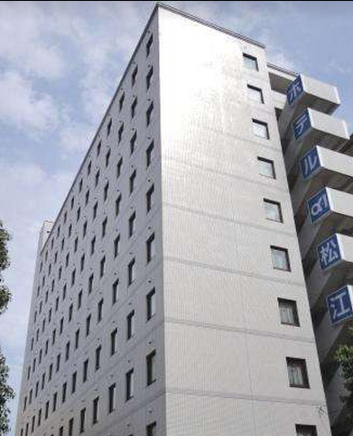
Matsue Universal Hotel  http://www.universal-group.co.jp/universaltop5.html | 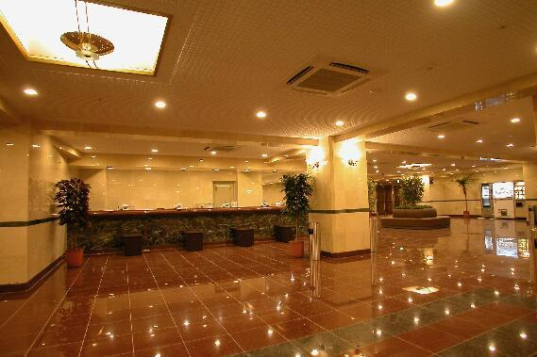
- Visa & Invitation Letters
A citizen of a foreign country who seeks to enter Japan generally must first obtain an entry visa, which is placed in the traveler’s passport, a travel document issued by the traveler’s country of citizenship.
A Letter of Invitation is a proof that your paper submission and registration application are accepted by the conference committee board. It will be stated in English and may help with your visa application. However, it does not guarantee you a visa.
Letters of invitation for Visa applications can be provided by the Symposium Secretariat. Invitation letters for visa purposes can only be sent to participants who have completed the registration process.
Visa applications are not the responsibility of the Symposium. Please ensure that you submit your application to the appropriate Embassy in good time. Letters of invitation WILL NOT be issued after 1 July 2017.
Please visit The Ministry of Foreign Affairs of Japan website for information and regulations about your visa application: http://www.mofa.go.jp/j_info/visit/visa/short/novisa.html#section2

Socializing Event
Join the socializing event and enjoy the fantastic attractions with us!
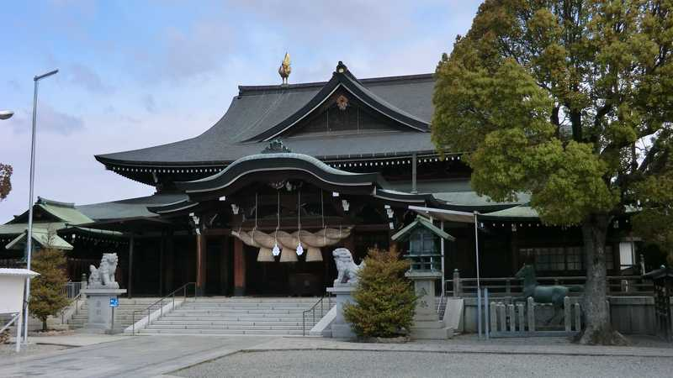
The Izumo Grand Shrine

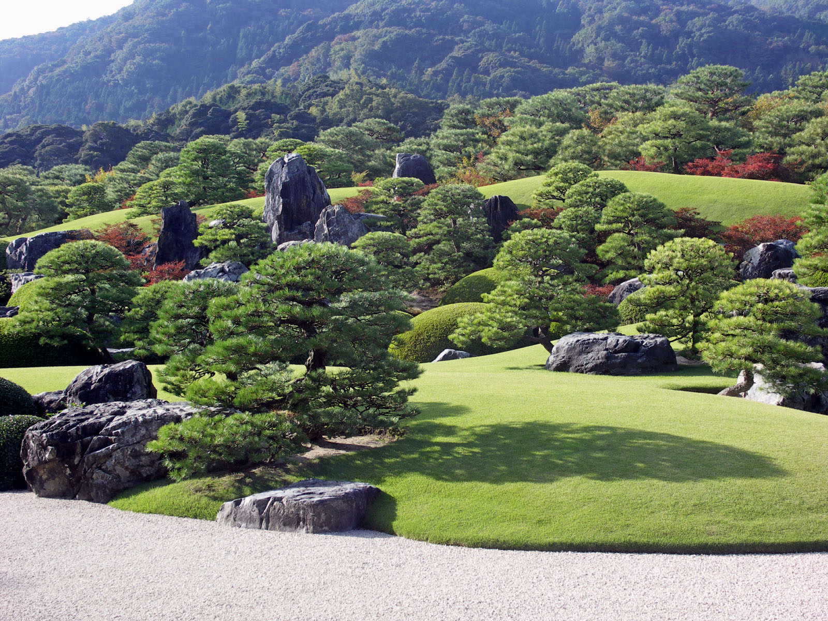
Adachi Museum of Art

Tour Schedule
09:00-17:00, 26 August 2017
Tour Rates
20,000 JPY per person
Reservation and Payment Deadline
1 August 2017

Contact Us
- 15th IS-GdR Secretariat
Email: secretariat@icgdr.com
Tel: +81 80 4012 9519 (Fawu WANG)
Tel: +81 70 3772 1906 (Zili DAI)
- Shimane University
Website: http://pcndr-shimane-u.com/english
Tel: +81 852 32 9878
Fax: +81 852 32 6469
Add: 1060 Nishikawatsu-cho, Matsue, Shimane 690-8504, Japan

